2020-2021 Tennessee 4-H Enrollment Form

First Name: _______________________________ Last Name: _____________________________________

Address: ___________________________________________________________TN____________________
Street Name City State Zip Code
Parent / Guardian (1): _________________________________ Phone #: ______________________________

Parent / Guardian (2): _________________________________ Phone #: ______________________________
Grainger County Zip Codes
Blaine 37709
Bean Station 37708
Rutledge 37861
Powder Springs 37848
Thorn Hill 37881
Washburn 37888
Race / Ethnicity (Circle One): White Black Hispanic
Gender (Circle One): Boy Girl
Date of Birth: __________________________________
Grade (Circle One): 5 6 7 8 9 10 11 12
School Name (Circle One): Joppa Bean Station Rutledge Washburn Grainger High
Teacher’s Name: ____________________________________________

4-H Projects (Circle 3 or Less):
Judging Teams (Circle 2 or Less):
Dairy
Forestry
Horse
Land
Livestock
Meat
Poultry
Wildlife
Beef
Goat
Horse
Horticulture
Leadership/Personal Development
Line and Design
Nutrition, Health, and Fitness
Performing Arts/Recreation
Photography
Plant Science
Poultry
Sheep
Swine
Veterinary Science

Citizenship
Clothing and textiles
Communication/Public Speaking
Companion Animals
Computers and Technology
Consumer Education/Economics
Dairy
Electric
Engineering/Safety Science
Entomology
Forestry, Wildlife, and Fisheries
Food Science

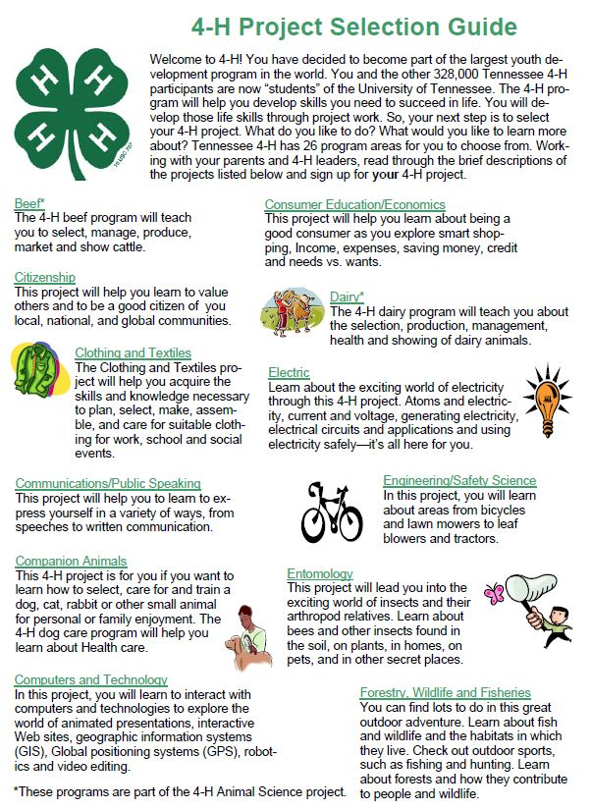

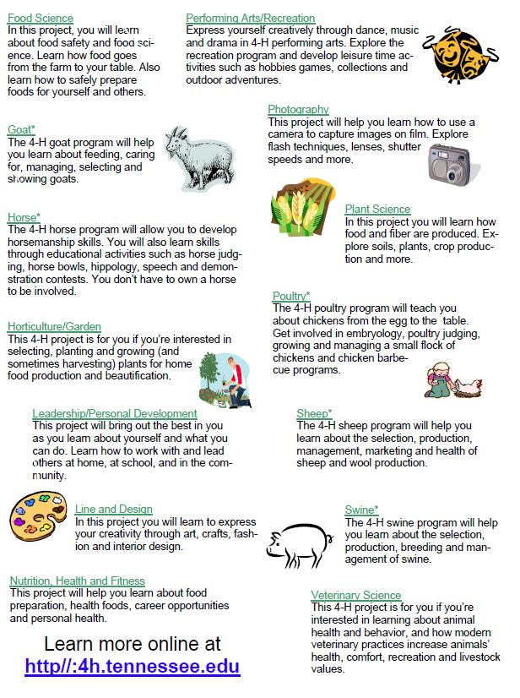

fghgh

