Explorer 4-H – 4th Grade
2020-2021 Tennessee 4-H Enrollment Form

First Name: _______________________________ Last Name: _____________________________________

Address: ___________________________________________________________TN____________________
Street Name City State Zip Code
Parent / Guardian (1): ___________________________________ Phone #: ____________________________
Parent / Guardian (2): ___________________________________ Phone #: ____________________________
Race / Ethnicity (Circle One): White Black Hispanic
Gender (Circle One): Boy Girl
Date of Birth: __________________________________
School Name (Circle One): Joppa Bean Station Rutledge Washburn
Teacher’s Name: ____________________________________________

4-H Pledge Grainger County Zip Codes
I pledge my HEAD to clearer thinking, Blaine 37709
my HEART to greater loyalty, Bean Station 37708
my HANDS to larger service, Rutledge 37861
and my HEALTH to better living Powder Springs 37848
for my club, my community, Thorn Hill 37881
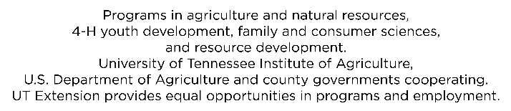
my country and my world. Washburn 37888

